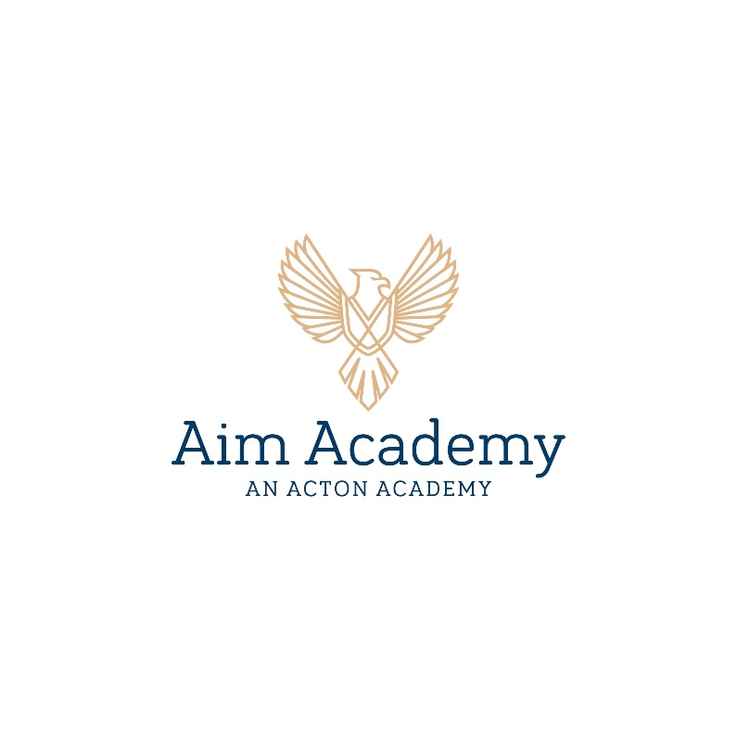

STUDENT QUESTIONNAIRE

Today’s Date: _______________________________________
Your Name: ________________________________________
What do you like to be called? ________________________

- What is the most challenging thing you have ever done?

- What are you most proud of?

- What do you think will be the most difficult part of beginning your Hero’s Journey at Aim Academy?

- What is it about Aim Academy that excites you the most?

- Which is more important? To work hard and accomplish your own goals? Or to help those around you who are struggling to accomplish their goals?

- What books or stories do you love? Why?

- What is the hardest part of being a good friend?

- What do you do when you are faced with a problem that seems insurmountable?

- What is one of your personal strengths that would benefit our community?

- Is there anything else you would like us to know about you?

